(Approx. 273 words)

Nemo (File Manager for Linux Mint)
By Cal Esneault, Cajun Clickers Past President and leader of many Open-Source Workshops & SIGs
May 2021 issue, CCCC Computer News
www.clickers.org
office (at) clickers.org

Mint is a Linux distribution based on Ubuntu. The Mint team typically customizes key utility applications to support its goal of stability and user-friendliness. Three examples are shown below.

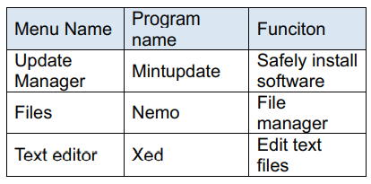
Nemo, the file manager, began around 2012 as part of the development of the Cinnamon Desktop, a project launched to avoid the use of Gnome 3 Shell.

Nemo is a “fork” of Nautilus, the Gnome file manager. Experienced Linux users often manage files using the command line. See an example of the “terminal” approach below.
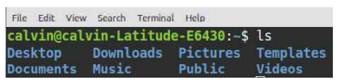
Average users, however, prefer the Graphical User Interface (GUI) that Nemo provides. Following is an example of the same directory listing referenced above but displayed by Nemo. The left-side pane provides easy navigation among parts of the overall file structure. The files can be listed in a variety of ways. Here, graphical icons are used. Other options include a detailed list view and a compact list view just showing names.

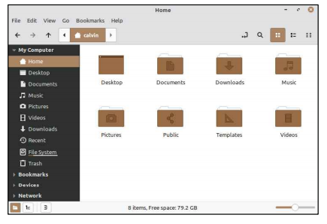
To facilitate moving files around, Nemo offers an “Extra Pane” view (shown below). The listing on the left is in icon view, while the listing on the right is the detailed view. In addition, files can be moved back and forth between folders using the drag-and-drop method.

There are many more features available to enhance your file organization. For example, you can add “bookmarks” to the navigation pane to speed your access to frequently used file areas. Be sure to investigate this important application if you use Linux Mint.

